University of Pittsburgh at Johnstown

Electrical and Computer Engineering Department SENIOR DESIGN COE1199

Cycle Statistic Tool

Weekly Memorandum
To: | Maddumage Karunaratne
From: | Jacob Hoffman  Cody Klingler

cc:
Date: | 03/23/2021

Re:

Achievements:

Cody: The permanent assembly that will attach to the crank arm of the bicycle was created. The assembly is compact and does not protrude from the crank arm. The strain gauge that failed last Tuesday was replaced. The container for the primary microcontroller, display, and a few other modules was attached to the bicycle. This container was also modified to fit a power switch and allow a charging cable to be connected to it. Classes for microcontroller measurements were created in an effort to make the code more maintainable. A permanent solution to the tire’s IR sensor was created from an acrylic sheet and tin foil. This means that the IR sensor is no longer mounted by the tread of the tire, but instead the axle.

Jacob: The trip view page was re-designed. The user has access to start, pause, and end buttons. Additionally, the user is to be alerted with bluetooth scan results if they select start and are not connected to the CST. This alert will also prompt the user when the trip page is initially opened. The trip page also lists all the selectable goal profiles (this consists of each user created goal profile). Whenever a bluetooth connection is active and a trip is being recorded, each new recorded entry captured by the application via bluetooth will be presented to the user. This will consist of the most recent statistics recorded. The code for connecting to bluetooth was re-designed, as well, but this part of the application is still not working properly.

Issues Encountered and Solved:

Cody: One of the strain gauges failed and was replaced. When the crank-arm-circuit was originally assembled the VIN wire was mistakenly connected to RESET. This took some time to troubleshoot.

Jacob: None.

Issues Encountered and Unresolved:

Cody: None.

Jacob: The mobile application’s bluetooth connectivity is still not working. Jacob has tried setting up different plugins, but none of them have worked. There is not a native bluetooth low energy framework for Xamarin, but a developer should be able to access the native iOS/Android bluetooth low energy frameworks within the corresponding project files to make custom code for connecting to bluetooth.

Goals and Tasks For Next Week:

Cody: Cody will assemble the primary microcontrollers circuit and fit it in the housing that was mounted on the bike. This includes soldering the modules to proto boards and wiring the battery, switch, and charging port. Once this is done weatherproofing can begin. The microcontroller code will also have the new class implementation completed, and given that the mobile app is ready bluetooth will be tested.

Jacob: The bluetooth connectivity to the CST needs to be finished. Once this is done, saving measurements from the device needs to be tested.

Project Schedule:

Cody: Gantt was adjusted to account for bluetooth testing being delayed again. I also moved back testing accuracy of measurements, weatherproofing.

Jacob: Coding the mobile application is scheduled until 04/03/2021. The scheduling for testing bluetooth was delayed on the GANTT chart.

Project Logbook:

Cody:
03/16/2021 - 3 hours
I implemented a 3.3v hx711, but the primary strain gauge has failed for some reason. I tested it with a multimeter several times and tried to reflow the solder joints. I think that a wire must have been broken while I was handling the crank arm. Putting the probes of the multimeter on the strain gauge gave the correct resistance, but placing them on the solder joints showed that there was no connection. I had to order strain gauges for the THIRD time.

03/20/2021 - 2.5 hours
extracted a switch from some old electronics that I had. Machined holes for charging port and power switch into the box that will contain the primary microcontroller and display.

03/21/2021 - 5.25 hours
Created a permanent solution for the IR sensor on the tire. Cut a half-disc from an acrylic sheet, applied aluminum to the half-disc, and glued it to the center of the tire on the bicycle. I also painted the metal areas of the bicycle near this so that they do not reflect IR. Threaded holes were found by the tire of the bike that allowed easy mounting of the ir sensor. Testing the new IR set up yielded results without dipping. Mounted the box that will contain the primary microcontroller to the handlebars. Began overhauling code that makes it easier to modify by setting up classes for measurements and update behaviors.

03/22/2021 - 10 hours
Applied a new strain gauge to replace the one that broke last monday. Created a permanent circuit to be placed on the crank arm. composed of arduino, hx711, protoboard, wires, resistors. Small enough to fit onto the pedal arm and not stick out. Unfortunately the HX711 has to have a 5V input for the VDD (digital logic), so we will have to use a USB battery bank to power our arduino.

Jacob:

03/15/21 - 4 hours

The current BLE code was set up to allow a scan to be executed by the app, but no devices are showing up for the user to select. There is a list on the display that is binded to an observable collection. The scan method is saving results into this list. But, the user is being displayed nothing. The correct device permissions have been set up.

03/19/21 - 5 hours

We have been having trouble figuring out exactly why the plugin is not currently working, but we are still unable to detect any bluetooth devices. I decided to try a new plugin called Reactive Bluetooth (https://github.com/xabre/xamarin-bluetooth-le). Unfortunately, this required deleting the existing bluetooth code and setting up a new bluetooth view model for the trips page.

03/20/21 - 6 hours

Finished up a bluetooth implementation using Reactive Bluetooth plugin, but unfortunately it gave us the same issue. I am wondering if there is something I am not implementing correctly with respect to the display list, or if there is something not usable when considering these plugins. The Reactive Bluetooth plugin was uninstalled and the original Plugin BLE plugin was re-implemented. However, we still are unable to detect any bluetooth devices with the scan method.

Task Division:

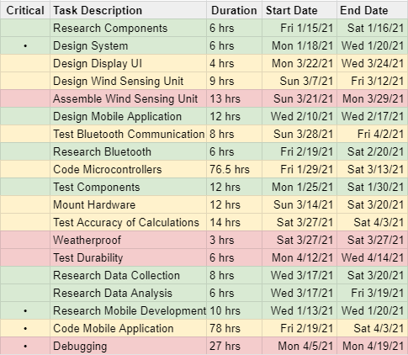
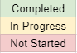
GANTT Chart:

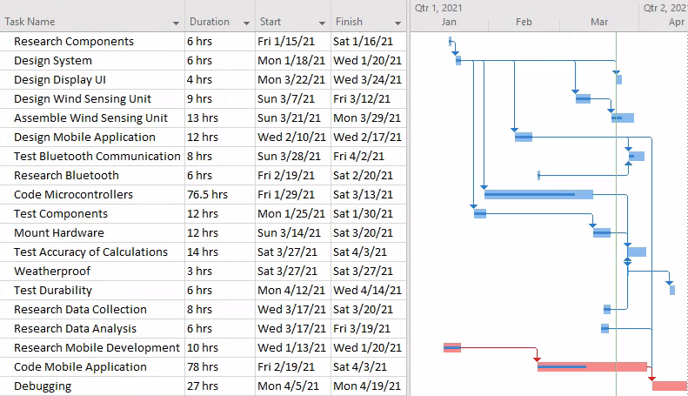

Bill of Materials:

